Client
Holiday Village - Lancashire

Mains water meter information
Size (mm) | 15-28 |  | 32-50 |  | 75-100 |  | 125-200 |  | Above 200mm
Serial number | 04C123234/07C325145
Readings (1) | Meter 04C: 4670734467073 |  |  |  | Time: | 10.30am
Readings (2) | Meter 07C:465821Meter |  |  |  | Time: | 10.30am

Leakage Activities
Acoustic sounding | ✓ | Correlation |  | ✓ |  | Ground microphone |  | ✓ |  | Environmental Inspection |  | ✓
Other | Inspection of all pipework connections
Pipe traced | n/a | CAT & Genny |  |  |  |  |  |  | Distance
Pipe correlated | Accelerometer |  | ✓ |  | Hydrophones |  |  |  | Distance |  | 120m approx

Background Survey Information
Water consumption through both meters supplying the site is consistently higher than expected, suggesting leakage or other unidentified water consumption on the network around the park.

Previous survey work in 2015 identified a number of leaks around the park which were repaired.

Between the two water meters, there is a constant overnight flow of approx. 5.3m³ per hour (5,300 litres per hour). This constant flow of water overnight equates to an excess cost of £169.18 per day and over the course of one year, this equates to an excess cost of £61,749.24.

Summary of Survey
Leakage Survey Activities

All water connections and fittings (valves, fire hydrants, taps, etc) throughout the park were acoustically sounded for leak noise, with particular attention towards areas that were communicated to be constantly wet.

All pipework connections acoustically sounded for leak noise were also inspected for any visible leaks on above ground connections and fittings.

A number of potential areas of leakage were found whilst carrying out the acoustic sounding on the park. Other areas of acoustic noise could be attributed to water use or boilers running – these plots were revisited to check the noise being created by other means had subsided.

The areas that were investigated for leakage are:

- Windsor – plot 29/30 – Large leak pinpointed on 3” PVC underground pipework;
- Regents – plot 24 – Good leak underground

Detailed acoustic sounding and leak noise correlation was carried out to pinpoint the exact area of leakage in both locations. The leak at Windsor was excavated by park staff to confirm the exact location during the site visit which confirmed the leak to be from a push-fit collar. The leak at 24 Regents was marked up with blue spray paint.

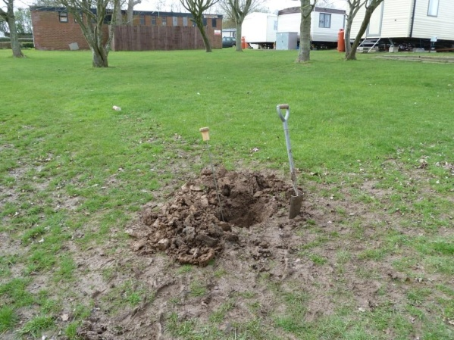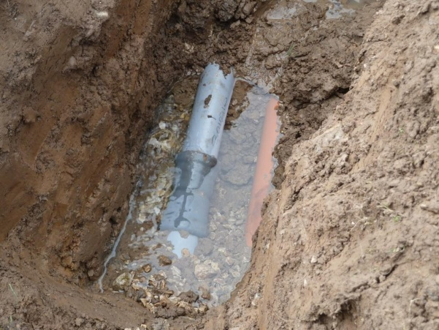
Leak 1 location – rear of Windsor plot 29 Leak 1 location – leak on push-fit collar

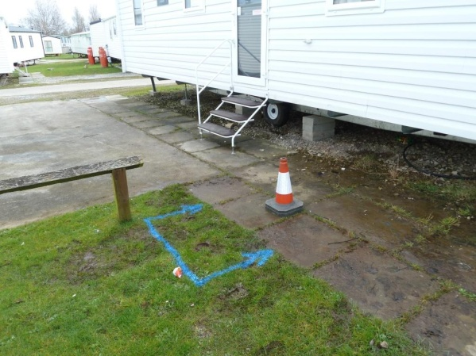
Leak 2 location – Regents plot 24

A number of smaller visible leaks were identified throughout the survey as follows:

Park Area | Plot | Fault
St Lukes | 37 | Drip on connection
Windsor | 4 | Drip on stoptap
 | 105 | Drip on stoptap
 | 156 | Drip on stoptap
Castle | 4 | Drip on stoptap
 | 20 | Drip on drain valve at rear
Westchester | 12A | Drip on stoptap
Regents | 172 | Dribble on fitting
 | 69 | Dribble on fitting - Paul sorted 06 April
London | 102 | Dribble on fitting - Paul sorted 07 April?
Kensington | 10 | Washine machine tap leaking (under decking)

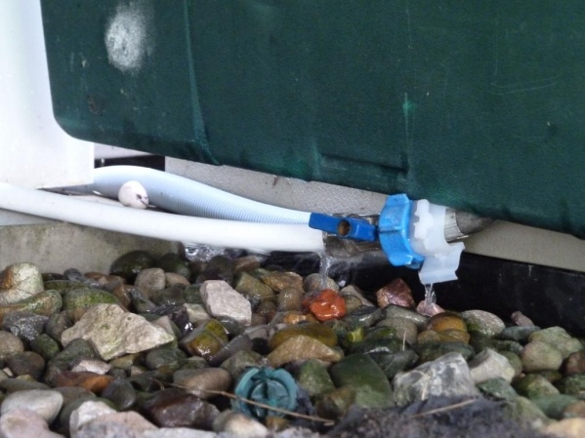
Leak on washing machine tap at Grosvenor plot 10

All internal points of water use within the touring block, launderette, shop, leisure facility and bar/amusement area were also checked for correct operation. All points of use were found to be operating ok with the exception of the urinal set in one of the men’s toilets in the amusement area, which was found to be constantly flushing/filling at a rate of approximately 3 litres per minute (0.18m³/hour). This urinal constantly running alone is an excess cost of £2,097.14 per year.

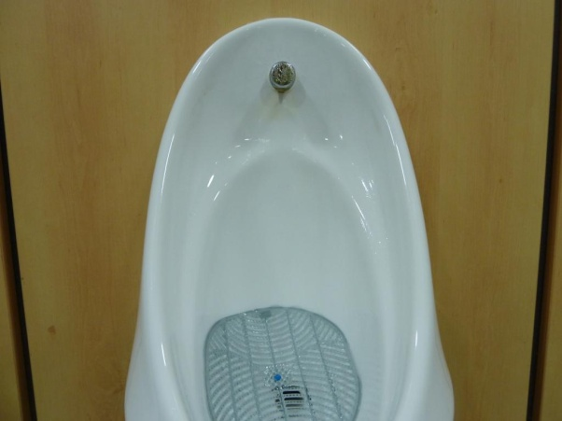
Urinal cistern running constantly in amusement area toilets

Summary & Recommendations
Summary:

- All water connections and underground fittings (valves and fire hydrants) were acoustically sounded for leak noise and checked for visible leaks;

- Two significant ground leaks identified:
- Rear of Windsor plot 29 – leak on 3” PVC main;
- Regents plot 24 – good leak on small diameter pipework close to or under slabs.

- A number of minor above ground leaks identified;

- Urinal cistern running in amusement area in men’s toilets;

- Indoor pool top up running constantly – need to check whether this is still occurring overnight;

- Very limited number of isolation valves to confirm leak volumes or to isolate sections of the park.

Recommendations:

- Excavate, locate and repair all leaks with appropriate fittings;

- Repair all minor above ground leaks;

- Re-check flow of water during early hours to assess volume of any remaining leakage;

- Install water meter (and data logger?) to indoor pool top up pipework in main swimming pool plant room. Alternatively (in the short term), isolate this supply for a night and reconfirm minimum night flow;

- Long term, the lack of isolation valves and knowledge of the main runs of larger diameter pipework around the park will require a full leakage survey to be carried out each time the flow rate rises unexpectedly. It also means that each metered supply must be shut off to carry out any remedial work, unless carried out with the network under full pressure. It is recommended that additional pipe tracing work is carried out and isolation valves installed on key pipework intersections.

Survey carried out by
Engineer | H2O Building Services | Date | 5th,6th & 7th April 2016

