Client
Tyre Store, Shropshire

Mains water meter information
Size (mm) | 15-28 | ✓ | 32-50 |  | 75-100 |  | 125-200 |  | Above 200mm
Serial number | 01-2345678
Readings (1) | 2565.911 |  |  |  | Time: | 11:54 27 May 2016
Readings (2) | 2567.352 |  |  |  | Time: | 15:12 27 May 2016
Location | Meter located in forecourt under small circular plastic lid.

Leakage Activities
Acoustic sounding | ✓ | Correlation |  | ✓ |  | Ground microphone |  | ✓ |  | Environmental Inspection |  | ✓
Other | Isolation of rising main (limited by not operating fully)
Pipe traced | ✓ | CAT & Genny |  |  |  |  |  |  | Distance |  | 36.5m
Pipe correlated | Accelerometer |  | ✓ |  | Hydrophones |  |  |  | Distance |  | 36.5m

Background Information
Recent meter readings show an increase in water consumption through the meter, which does not correspond to any increase in legitimate water usage within the premises. South Staffordshire Water have marked a position just outside the external wall be the rising main for excavation.

The premises were previously a petrol station. There are visible scars of the fuel pump locations in the concrete forecourt.

Water is used on the site for domestic use in the kitchen area and staff & customer toilets. A limited amount of water is also used for topping up screenwash within the workshop area.

Activity Summary
Pipework & Metering

The water meter is located in the forecourt roughly in line with the front door of the premises. A further small chamber in the footpath contains a brass stoptap which isolates the water supply prior to the meter.

The rising main is copper pipework, which rises in the corner of the staff toilet. The pipework was traced out from the meter (clipped on to the brass body of the meter) the route of which can be seen on the attached site sketch. From the rising main, 15mm copper pipe is surface clipped around the building to supply all points of water use.

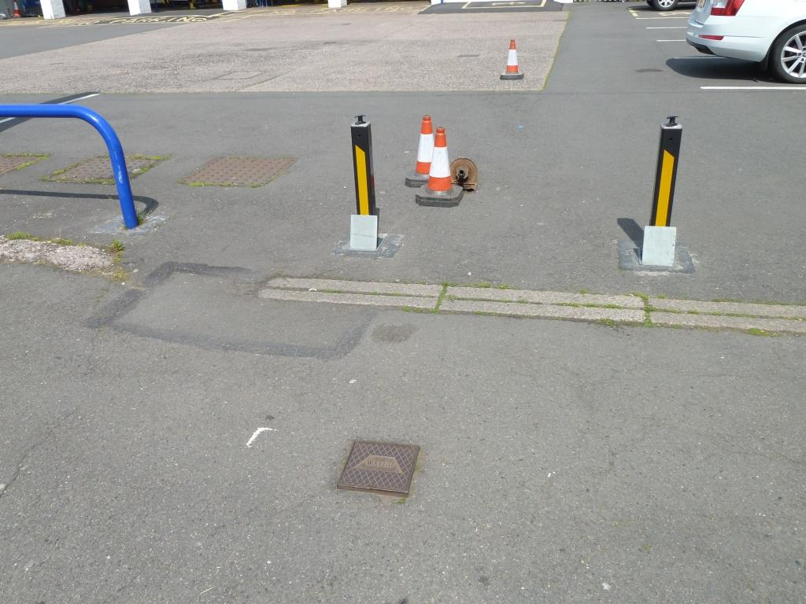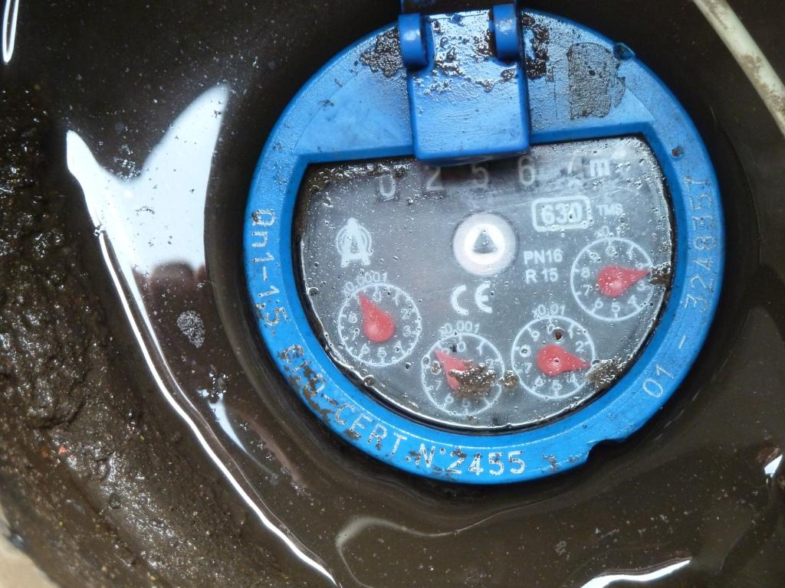
Stoptap and meter locations in forecourt Meter

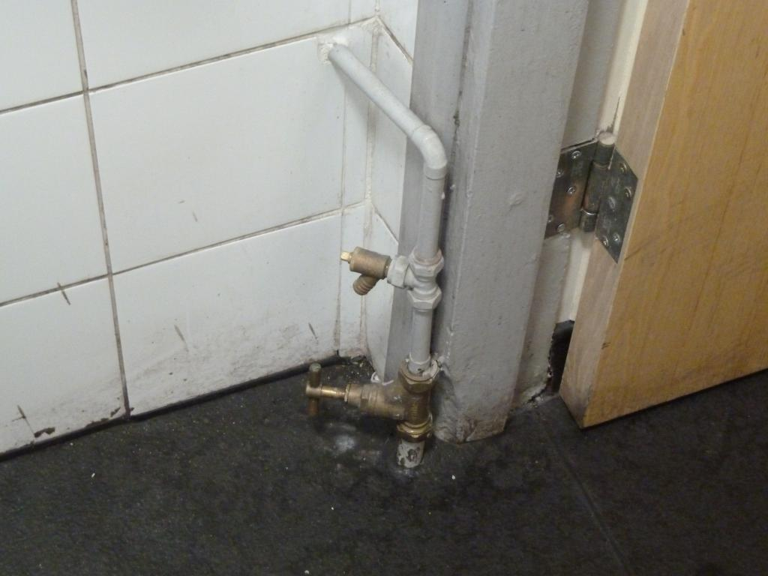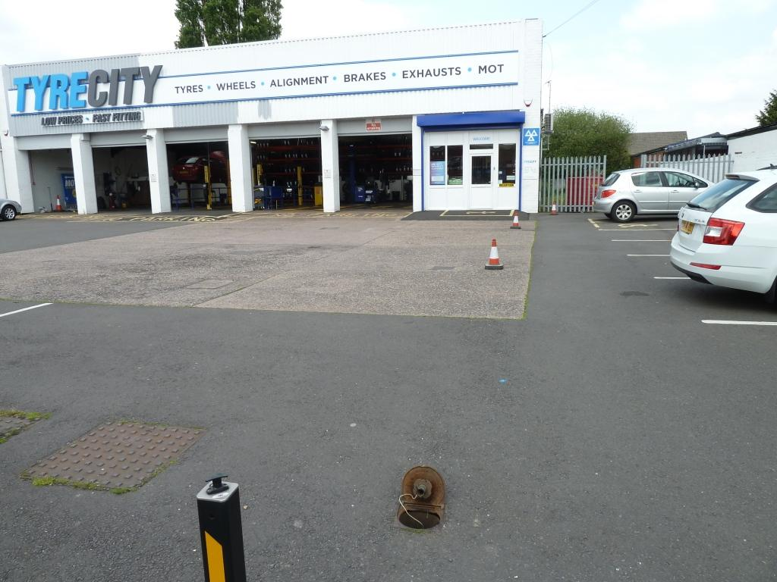
Rising main in staff WC External line of pipework up to building (cones)

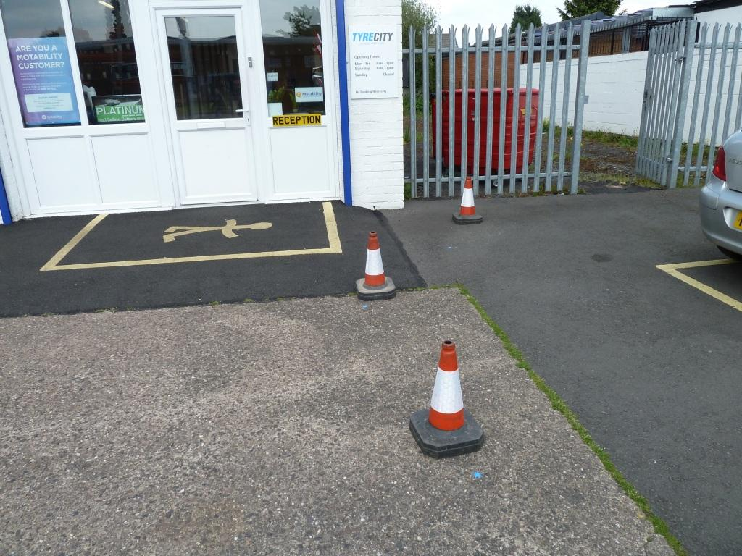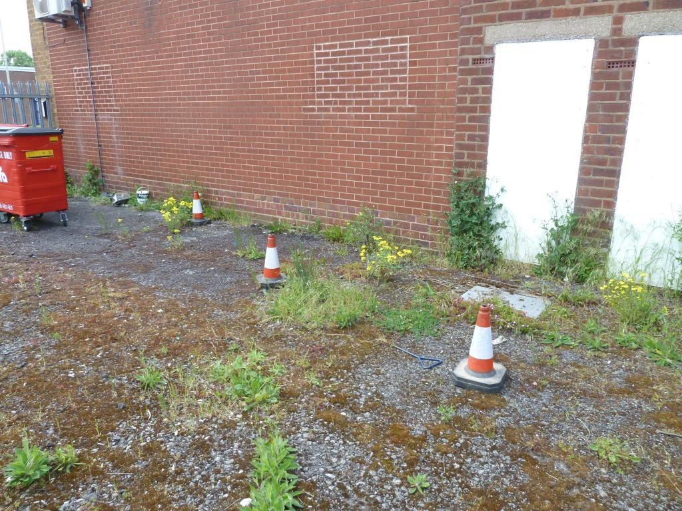
Line of main curving round building Traced line of pipework alongside building

Leakage Survey Activities

All points of water use were identified and checked for correct operation - all were found to be operating ok. The main incoming pipe (rising main) was located and the isolation valve closed (valve on rising main does not operate fully though) whilst the meter was checked to perform a leakage test.

With no other water use on the premises, the meter was confirmed to be recording water consumption at a rate of 7 litres per minute (10m³/day). This equates to an excess cost to Tyre Store of £19.50 per day and over the course of one year, an excess cost of £7,117.50.

The route of the copper pipework was traced out from the water meter in the forecourt into the premises (see attached site sketch).

Audible leak noise could be heard on the rising main and at the water meter. Leak noise correlation was carried out which gave a clear leak position just in front of the high metal fence outside the front entrance to the premises. Although the whole area was acoustically sounded for any surface noise to confirm the correlation, none could be found. This may be due in part to the high amount of ambient noise being created by the constantly busy road running past the premises. The ground microphone was also used in this area but no noise could be identified.

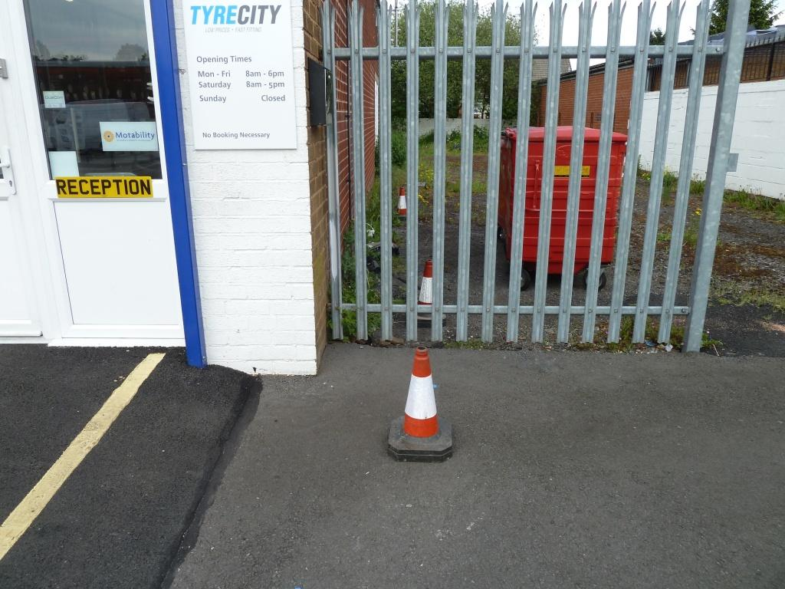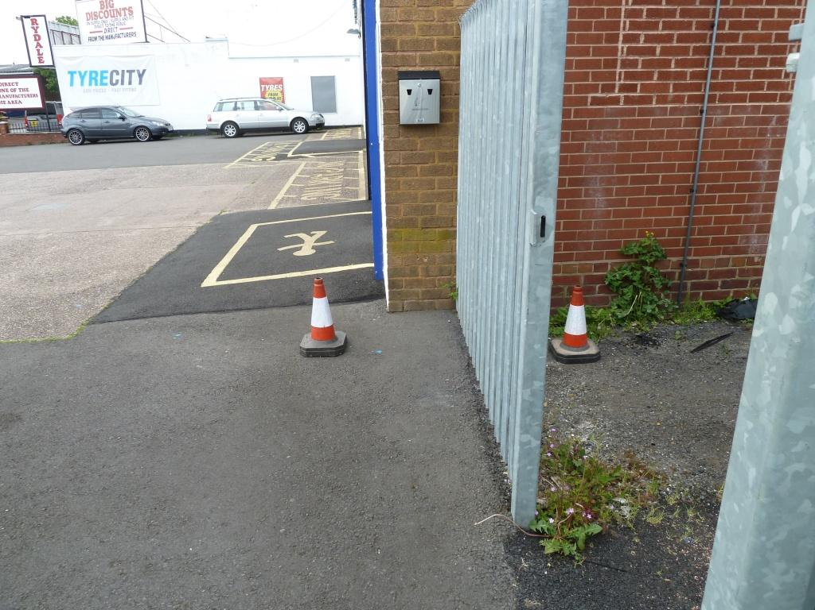
Likely leak position just in front of the metal fence Excavate behind fence first (cone on RIGHT) to check
(no surface noise to confirm correlation however) leak isn’t here before breaking into new tarmac in front
of fence (cone on LEFT)

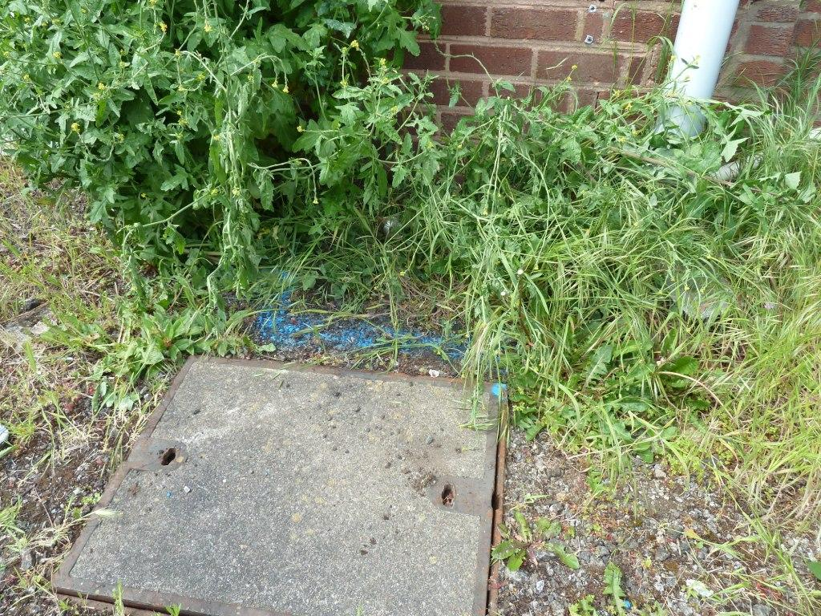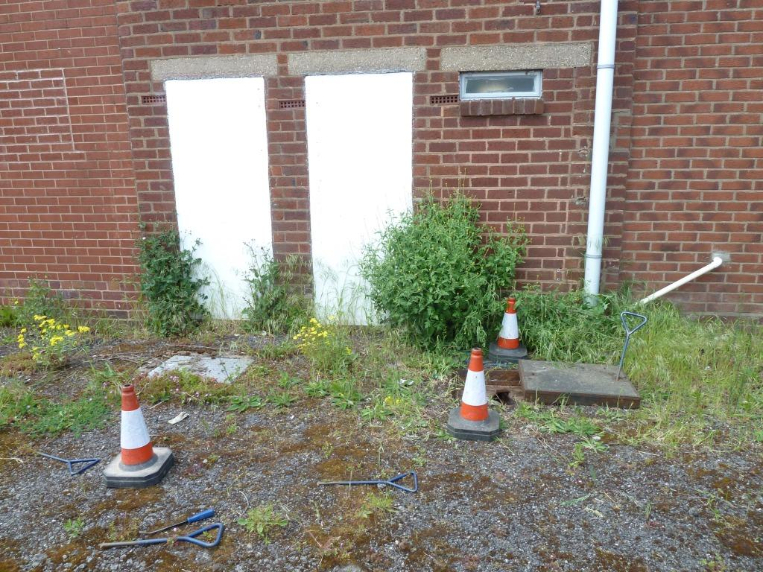
South Staffs area for investigation – IGNORE! Line of main into building (cones marking route)
Leak noise heard on building wall at this point
believed to be originating from rising main

Summary & Recommendations
Summary:

- Below ground leakage confirmed running at a rate of 7 litres/minute or 10m³/day costing Tyre Store £19.50 per day and over one year, £7117.50;
- The location of the leak is anticipated to be just in front of the high metal security fence to the right of the entrance to the premises but this would potentially require several excavations in tarmac to pinpoint;
- All water using fittings on the premises operating ok.

Recommendations:

- A full relay of the pipework would be most beneficial for the site. Given the age of the pipework, it is very likely that a repair will be carried out, the pressure reinstated and further leaks will develop on the pipework.

External pipework can be reconnected through the exterior wall of the staff WC via an Insuduct or Groundbreaker box into the 15mm copper pipework. Total distance to relay is approximately 35m.

NB: This quotation is for the pipework to be moled. If the pipework cannot be moled, a quote will have to be provided for open cut.
Should we encounter any unforeseen circumstances on site, we will contact you to discuss this and obtain authorisation before any additional costs are incurred.

Quotation

Relay 35m of barrier pipe across old petrol station using moling technique and pick up the supply in the Tyre Store staff kitchen under the sink and cap off old supply in toilet. Reinstate supply to check all ok. Backfill and reinstate excavated areas. We anticipate this work to take approx. 2-3 days to complete.

Please note this quotation is an estimate and all quotations are subject to change, as per above.

Our cost to carry out the above works: £XXXX + VAT

Annual Saving: £7,117.50

Survey carried out by
Engineer | H2O Building Services | Date | 27th May 2016

