Client
Leisure Park, Northumberland

Mains water meter information
Size (mm) | 15-28 |  | 32-50 | ✓ | 75-100 |  | 125-200 |  | Above 200mm
Serial number | 08UF123456
Reading | 215371.000 |  |  |  | Time: | 19:15 20 June 2016
Location | Main meter located in large chamber in edge of road at junction of The Perth and North Road – accessed with pair of small lifting keys.

Leakage Activities
Acoustic sounding | ✓ | Correlation |  | ✓ |  | Ground microphone |  | ✓ |  | Environmental Inspection |  | ✓
Other

Pipe traced |  | CAT & Genny |  |  |  |  |  |  | Distance
Pipe correlated | Accelerometer |  | ✓ |  | Hydrophones |  |  |  | Distance |  | 40m approx

Background Information
The minimum night flow to the park has recently increased from a minimum of around 0.7m³/hour to approx. 5.5m³/hour. This equates to unaccounted water consumption of 4.8m³ per hour and 115.2m³ per day. In financial terms, this is an unaccounted cost to the Leisure Park of £10.13 per hour and £243.07 per day.

This survey follows on from a number of previous visits during 2014/5 which include leakage surveys, pipe tracing and valve installation work.

Please note, prior to our latest visit on 20th June 2016, the site team had carried out a repair on a severed water connection and subsequently the overnight flow rate dropped from approximately 6m³ per hour to 2m³ per hour.

This meant that whilst the site team had achieved an instant saving of £202.56 per day, there was still approximately 1.3m³ per hour (31.2m³ per day/£65.83 per day) of water loss to find on park.

Summary of Survey
Leak Investigation Work

Plot 51 Morning View was checked first to ensure that there were no further issues on the underground pipework following the severed water connection found to the mobile home.

The sub-meter to Chariot View was monitored for a few minutes and found to be recording around 1 litre per minute, indicating a fairly tight network in this area. The small amount of consumption may be attributed to several minor underground leaks (weeps and drips from joints, etc) which are uneconomic to locate, but otherwise this area is not suffering from any significant leakage problems.

The new stoptap supplying Woodside was checked following the previous leak in June 2015. No leak noise could be heard on it.

An acoustic check on the pipework connections in Bambridge Court then identified two issues on pipework to plots 191 and 188. Further inspection of plot 188 revealed a leak on a compression fitting just beneath the ground. This was excavated and repaired immediately to enable accurate pinpointing of the adjacent leak to take place.

Leak noise correlation and acoustic sounding pinpointed the leak near plot 191 to a small patch of tarmac in the entrance to Woodside, where a connection used to supply plot 190 (plot removed to allow the road to Woodside to be constructed).

An overflowing WC was also identified in the main shower block. This was communicated to site maintenance for remedial action.

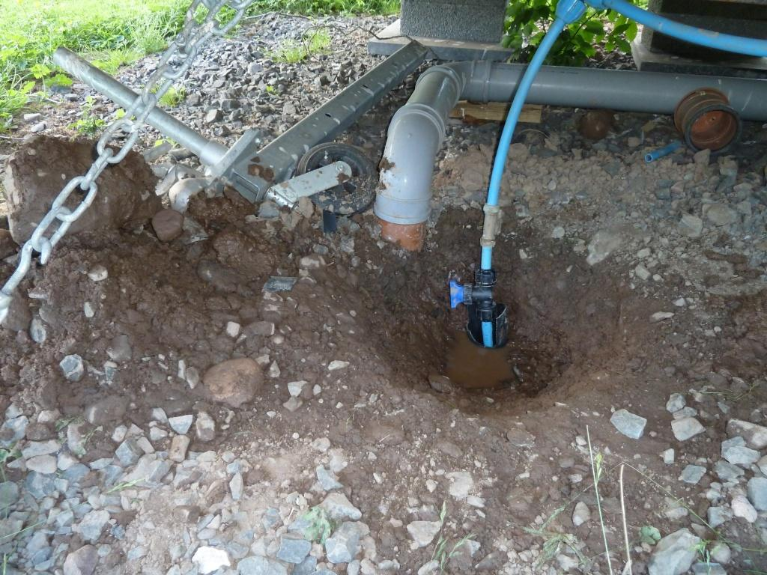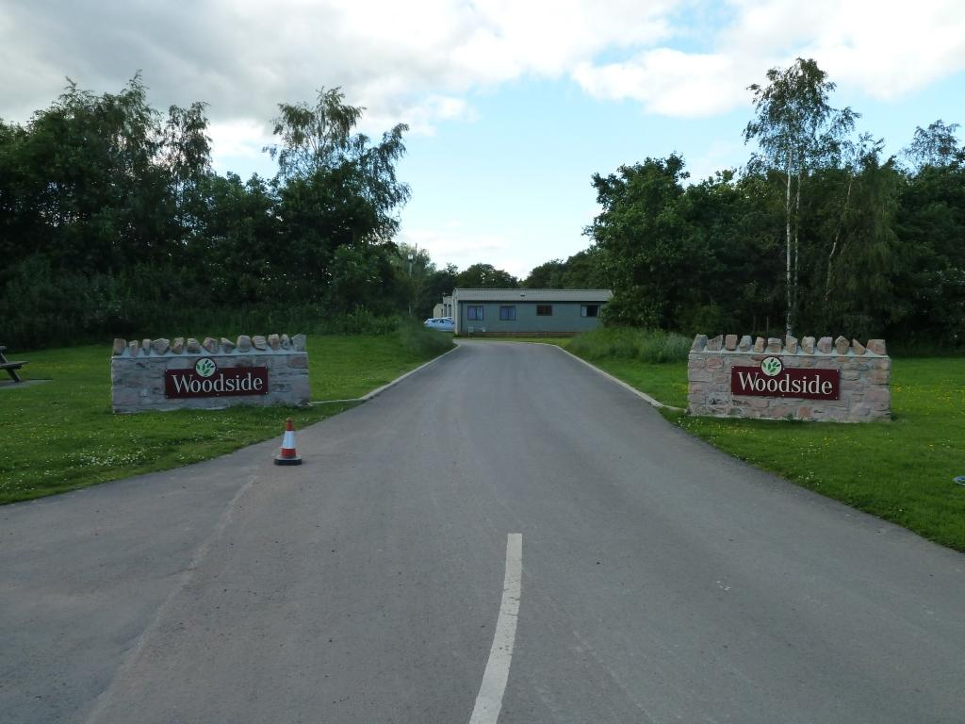
Leak repair plot 188 Bambridge Court Leak location (old connection to plot 190)

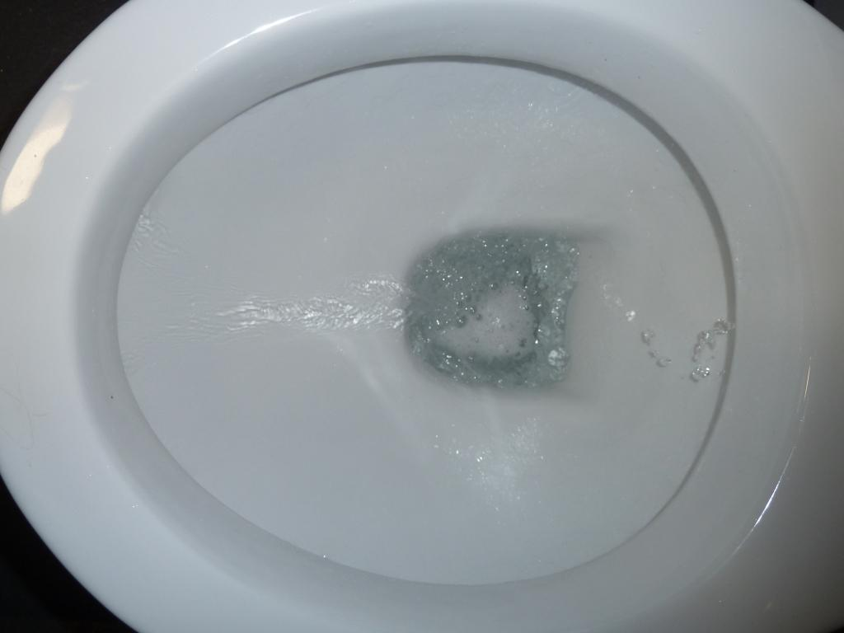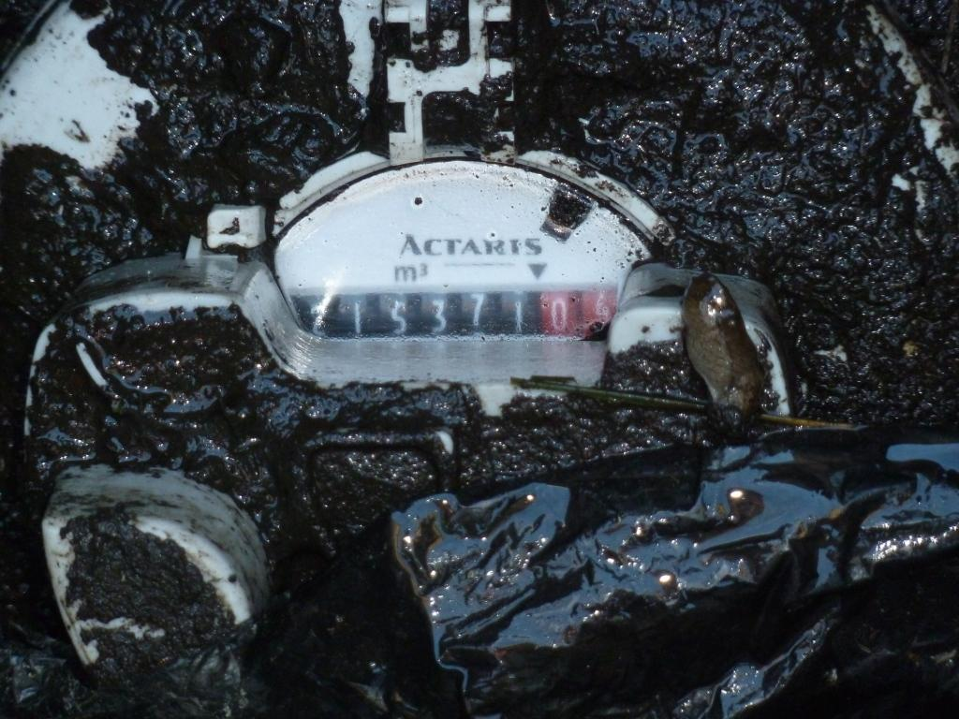
Overflowing WC in main shower block Main Meter

Summary & Recommendations
Once the three identified areas of leakage are addressed, it is expected that the minimum flow rate to site will reduce down to the previous minimum level of around 0.7m³/hour.

Summary:

- Significant leak identified on old connection to plot 190, in entrance road to Woodside;

- Leak identified on plot 188 Bambridge Court. Repaired at time of survey;

- Overflowing WC in main shower block.

Location of main leaks in Bambridge Court:
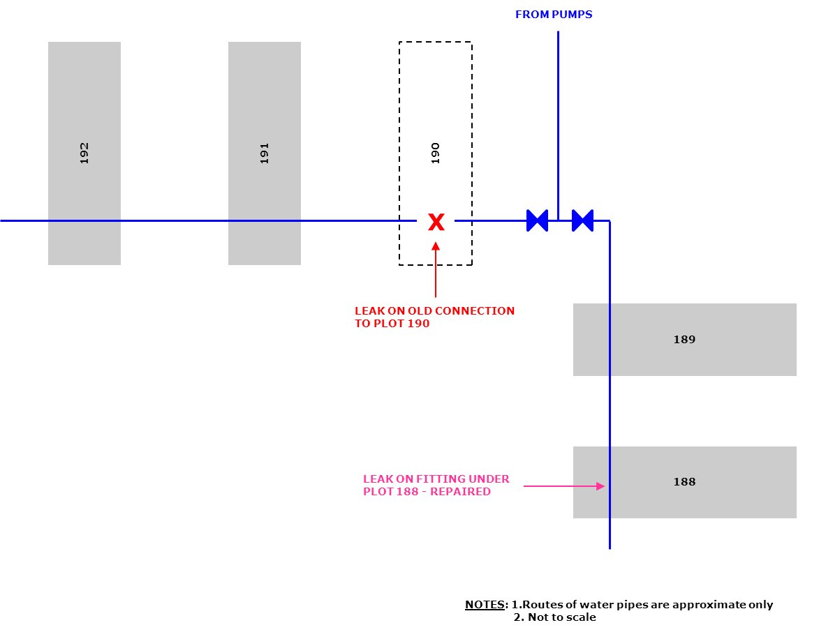

Recommendations:

- Repair all identified leakage issues;

- Continue to monitor flow logger for any further leakage issues that may arise.

Please see below data logger screenshots from the Leisure Park Main Water Meter 08UF001397 both before and after our leak detection visit.

Since our visit we have spoken to site who advised that the repair underneath the tarmac at Woodside has been completed. We reviewed the water data logger and found that the flow rate has once again returned to 0.7m³/hour.

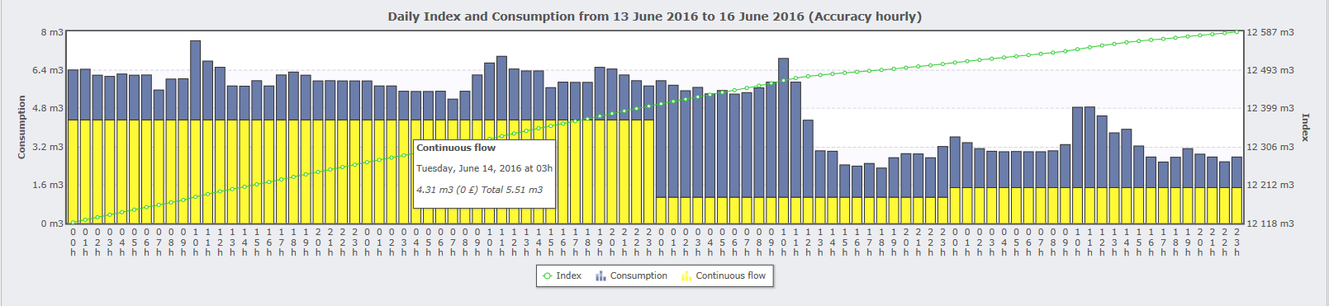
The above screenshot shows the constant minimum flow of at least 5.5m³ per hour overnight prior to any repairs being carried out.

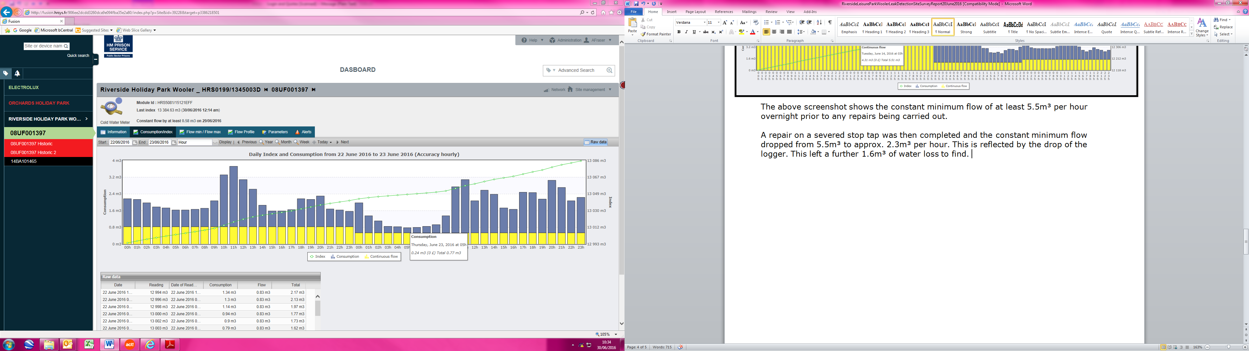
A repair on a severed stop tap was then completed and the constant minimum flow dropped from 5.5m³ to approx. 2.3m³ per hour. This is reflected by the drop on the data logger. This left a further 1.6m³ of water loss to find.

As detailed above, H2O Building Services attended site on Monday 20th June to carry out a water leak detection site survey and located a further two large leaks on site.

The leaks were pinpointed by our engineer and the site carried out the repair works during that week.

We then reviewed the water data logger after completion of the leak detection & repairs (above screenshot) on site and found that the data logger had returned to its normal flow of approximately 0.7m³ per hour and we had eliminated the remaining 1.6m³ of water loss on site.

Survey carried out by-Experts

Engineer: | H2O Building Services | Date | 20 June 2016

