Client
Holiday Park, Northumberland

Mains water meter information
Size (mm) | 15-28 |  | 32-50 | ✓ | 75-100 |  | 125-200 |  | Above 200mm
Meter Serial Number | 06UH654321
Readings (1) | 767536.210 |  |  |  | Time: | 13:23 24 May 2016
Readings (2) | 768008.000 |  |  |  | Time: | 14:20 26 May 2016
Location | Meter located off site across other side of golf course on Magda Drive, not far from railway bridge. In large chamber in footpath, accessed with one large lifting key.

Leakage Activities
Acoustic sounding | ✓ | Correlation |  | ✓ |  | Ground microphone |  | ✓ |  | Environmental Inspection |  | ✓
Other | Inspection of all pipework connections, internal pipework in pool area and kitchens, bar area and toilets
Pipe traced | n/a | CAT & Genny |  |  |  |  |  |  | Distance
Pipe correlated | Accelerometer |  | ✓ |  | Hydrophones |  |  |  | Distance |  | 300m

Background Information
The minimum night flow through the meter supplying Holiday Park has been consistently approx. 5.5 cubic metres per hour, suggesting leakage or other unidentified water consumption on the network around the park.

A constant flow of 5.5m³ per hour equates to an unaccounted consumption of 132m³ per day and an unaccounted cost of £9.95 per hour, £238.92 per day and £87,205.80 per annum.

The park contains approximately 740 accommodation units, together with leisure amenities including indoor and outdoor pool, bar/restaurant and owners spa area.

Summary of Survey
Pipework & Metering

The water meter supplying the park is located off site across the other side of the golf course. The large meter chamber is in the footpath and accessible using one large lifting key.

A check meter is installed on the opposite side of the golf course near the perimeter fence of the park.

Visible pipework around the areas of the park is typically MDPE (Medium Density PolyEthylene or more commonly known as blue poly) of varying age or black poly laid in the older areas. Some areas of the park have completely redesigned layouts with new sections of pipework. The older parts of the park are thought to be constructed using PVC or possibly cast iron or asbestos cement pipework. Main isolation valves are located around the park on the larger sections of pipework together with several fire hydrants.

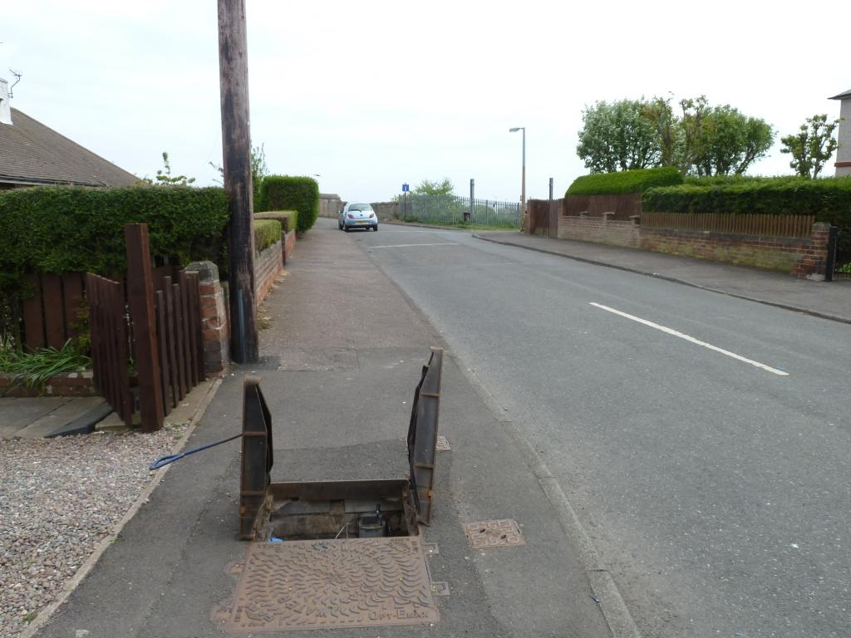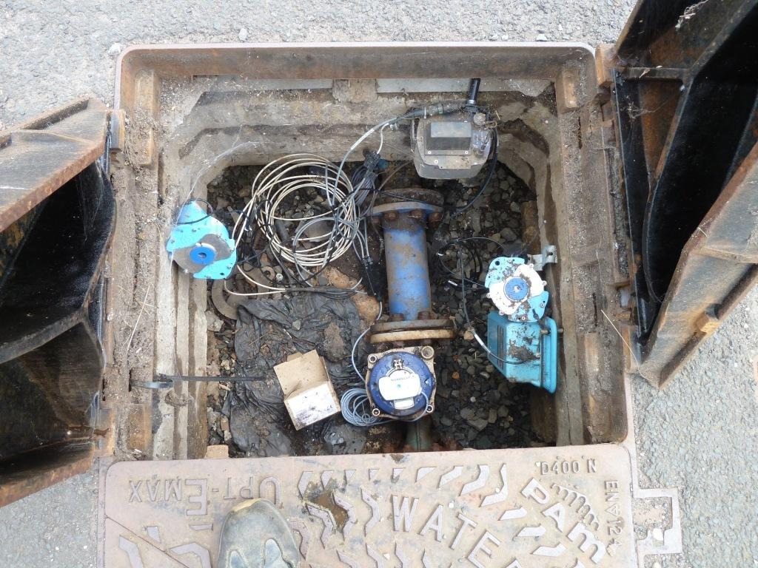
Meter location on Magda Drive Meter chamber and logger

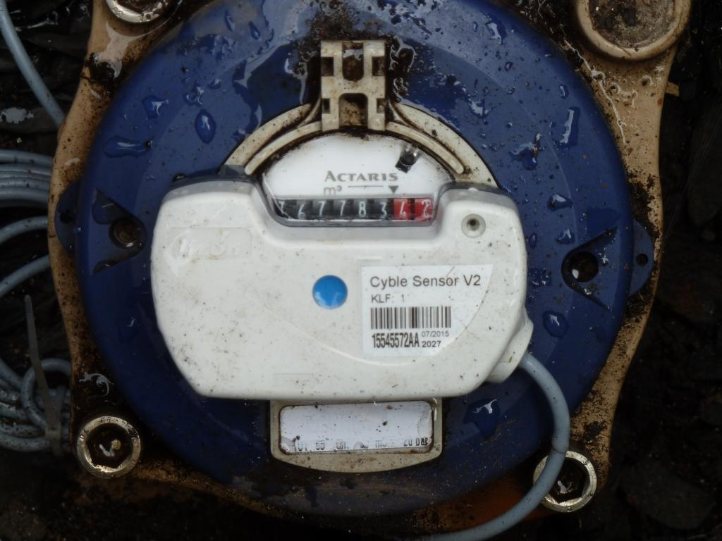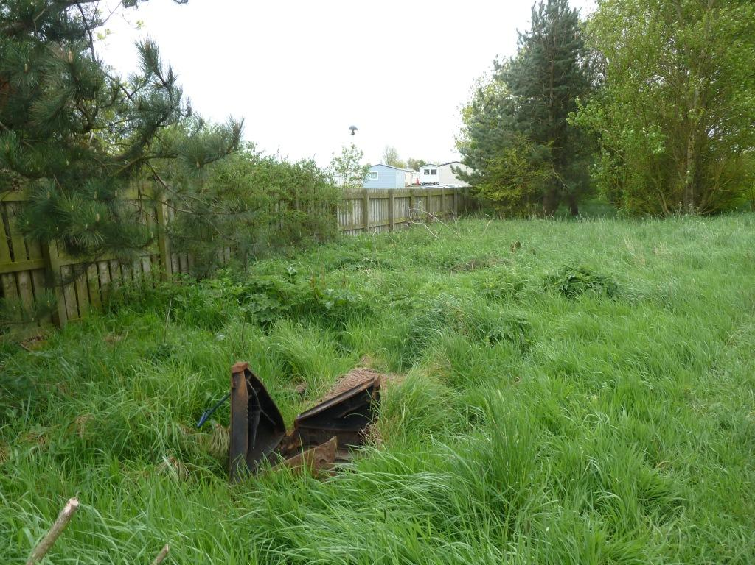
Meter Check meter location behind perimeter fence
(near plot 2 Golf View)

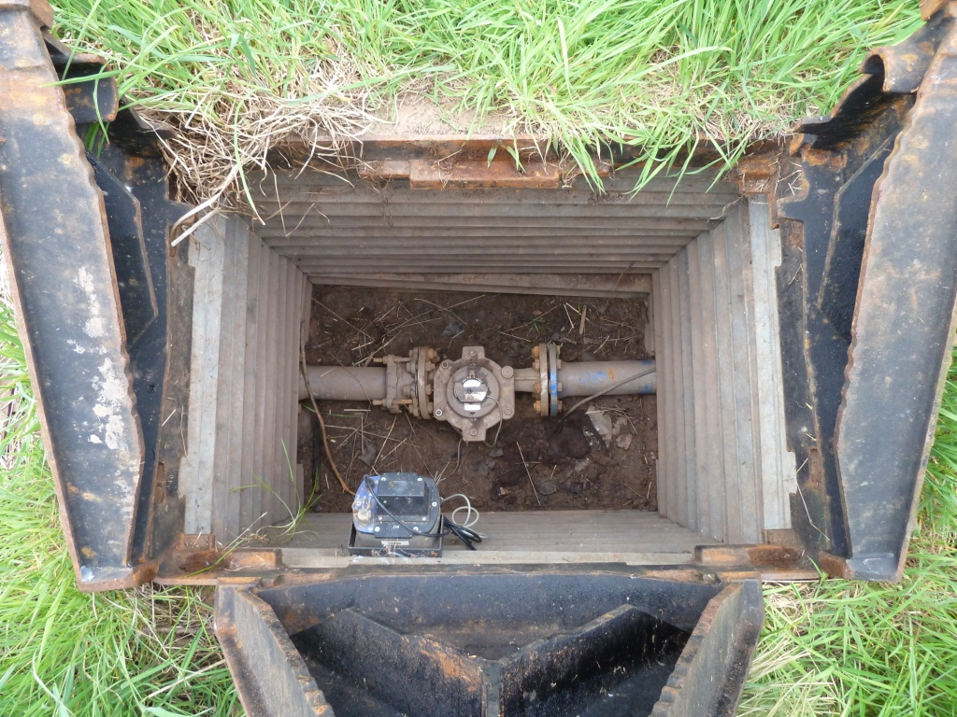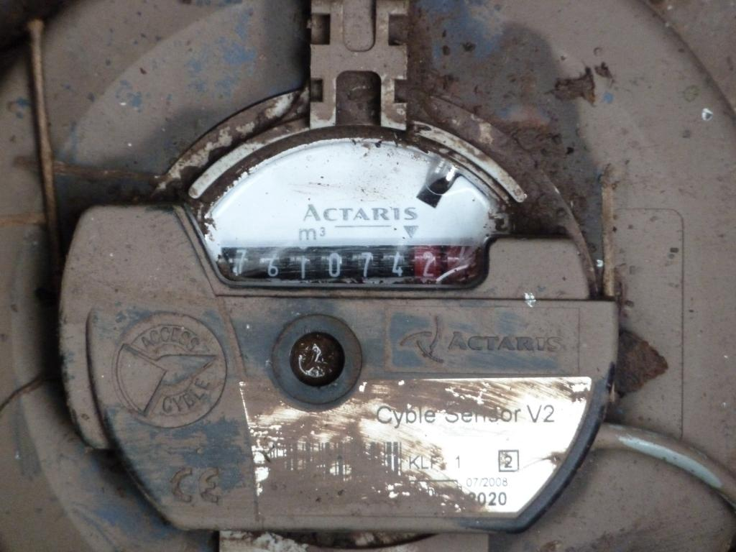
Check meter chamber Check meter

Leakage Survey Activities

All water connections on the park were acoustically sounded for leak noise (approximately 740 accommodation plots) together with all stoptaps, isolation valves and hydrants found. All connections were also inspected for any visible leaks on stoptaps and fittings.

A number of potential areas of leakage were found whilst carrying out the acoustic sounding on the park. Other areas of acoustic noise could be attributed to water use or boilers running – these plots were revisited to check the noise being created by other means had subsided.

Detailed acoustic sounding and leak noise correlation was then carried out to pinpoint the exact area of leakage in all locations. The locations of all confirmed below ground leaks are shown on the attached drawings.

Using meter readings taken from the main water meter and the check meter over a period of time, it was ascertained that the section of incoming pipework across the golf course does not have any leakage on it.

Summary of below ground leaks located on the park and estimation of leakage volume:

Leak | Location | Description | Volume (Estimated) |  | Pinpointed?
 |  |  | L/min | m³/day
1 | 38 Seasalt | Split on black poly | 44 | 63.0 | Yes
2 | 23/25 Long View | Failed joint? | 5 | 7.2 | No
3 | 12/13 Head View | Failed joint? | 5 | 7.2 | No
4 | 1/2 Eskimo Way | Failed joint? | 5 | 7.2 | No
Total |  |  | 59 | 84.6

Leak 1 was excavated and repaired during the survey which was found to be a long split on a 1” diameter black poly pipe, likely to have been caused by poor backfill material due to a brick being found on top of the pipe.

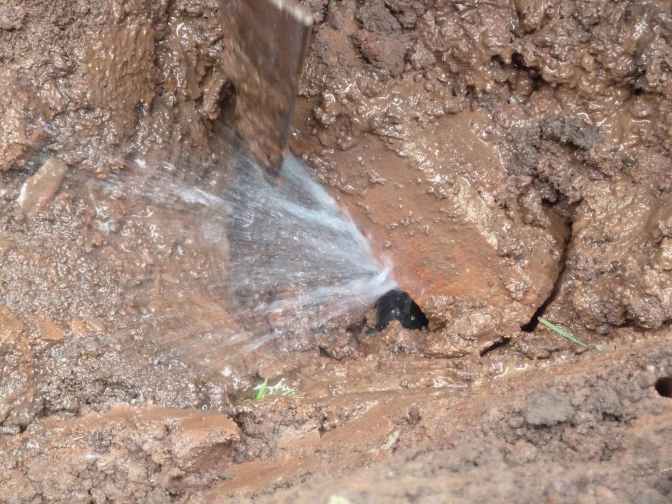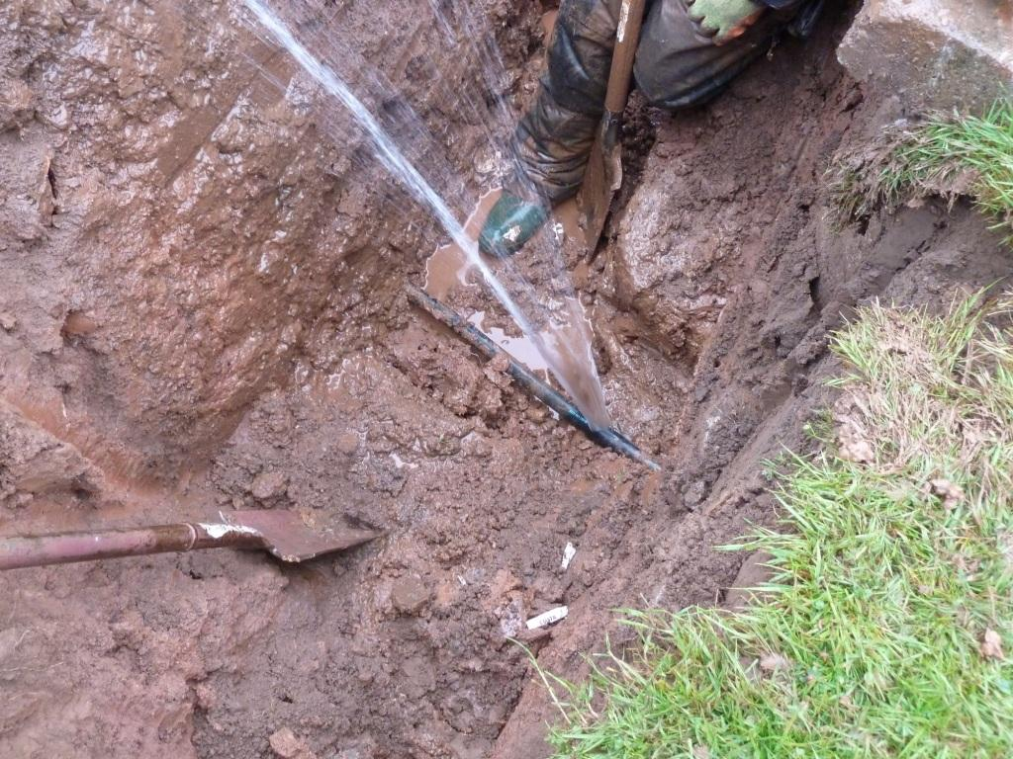
Leak location 1 – leak on black poly under brick Leak location 1 – split on 1” black poly

A number of smaller visible leaks were identified throughout the survey as detailed below:

Park Area | Plot | Fault
The Chariots | 23 | Leak on stoptap
 | 25 | Leak on stoptap
 | 16 | Leak on stoptap
 | 5 | 2x drips on fittings
Alnway Close | 48 | Dripping drain off valve
 | 48 | Leak on 25PE (kinked)
Golf View | 4 | Waste pipework disconnected
Golf Course | 3 | Drip on stoptap
Fairdrive View | 10 | Leak on stoptap
The Grove | 3 | Drip on stoptap
The Hills | 41 | Drip on fitting
 | 30 | Drip on stoptap
 | 19 | Drip on 2nd stoptap
 | 70 | Leak on Hep20
 | 70 | Waste pipework disconnected
 | 50 | Drip on stoptap
 | 54 | Drip on stoptap
 | 55 | Leak on Hep20
Eskimo Way | 36 | Leak on stoptap
Farmer Close | 17 | Drip on stoptap
Seasalt | 31 | Leak on stoptap
Kiel Court | 46 | Drip on stoptap
Head View | 13A | Drip on stoptap
 | 15A | Drip on fitting
 | 10 | Fire point running – 120 litres/hr  Needs new gate valve - broken
Central View | 11 | Drip on brass fitting
Lindyfarm View | 13 | Drip on stoptap
 | 11 | Leak on stoptap
Opp Security Hut |  | Drip on 25PE connector in hedge

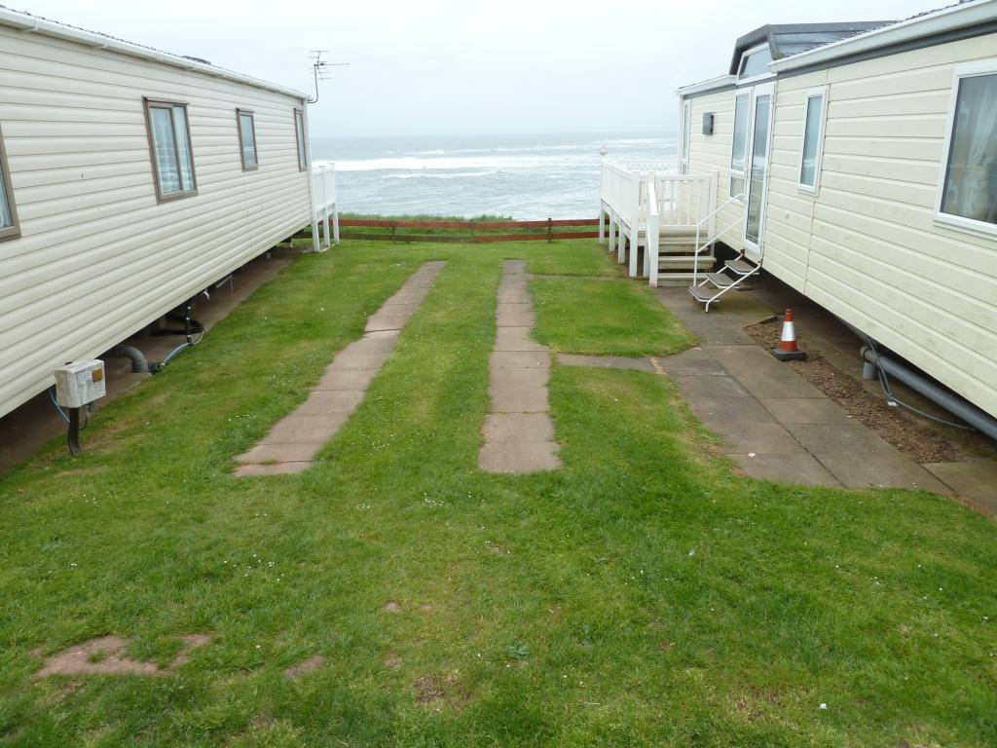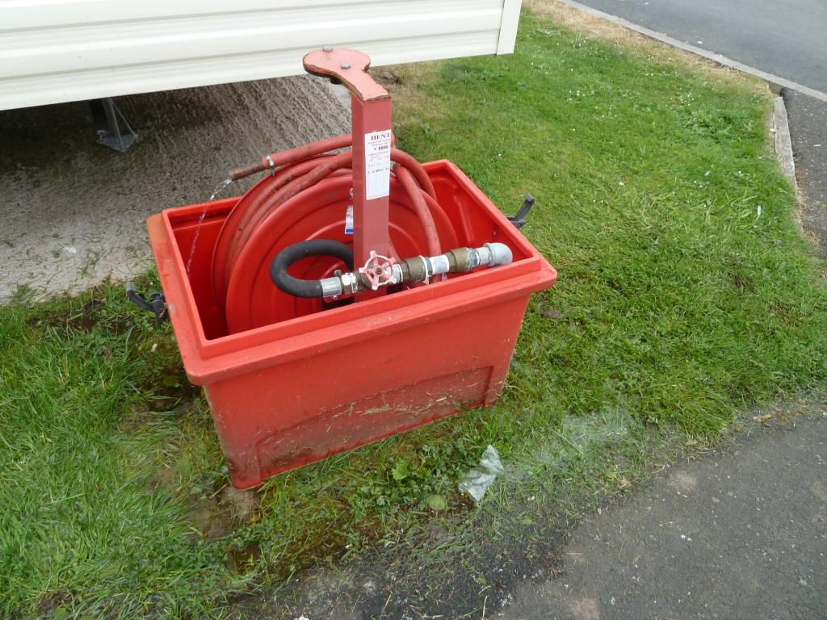
Leak location 2 – between plots 1&2 Eskimo Way Leak on fire hose reel – plot 10 Head View
(needs new gate valve)

All internal water using fittings (WC’s, Hand Wash Basins, Urinal controls, etc) within the entertainment and leisure complexes were also checked for correct operation. Two minor issues were identified:

1. Drip from overflowing WC cistern in Owners Club area. This was rectified at the time by adjusting the float valve in the cistern (see photograph below);
2. Non-concussive tap in the entertainment complex (men’s toilets, left hand basin, cold tap) found to ‘stick’ on when operated causing water to run to waste.

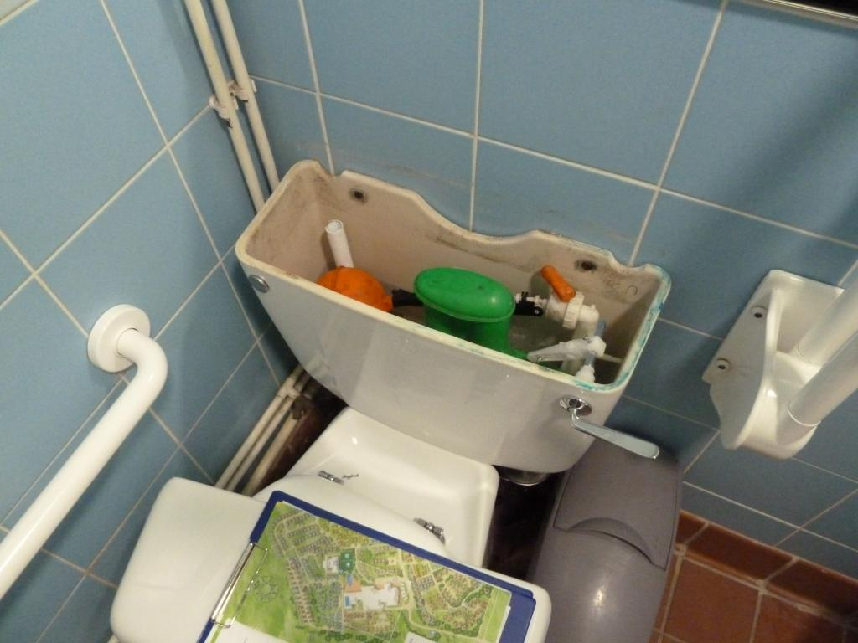
WC cistern in Owners Club – disabled toilet

Summary & Recommendations
Summary:

- All water connections and underground fittings (stoptaps, isolation valves and fire hydrants) were acoustically sounded for leak noise and checked for visible leaks;

- One significant leak identified on the below ground network at 38 Seasalt;

- Several other minor leaks identified (refer to table above) but unable to confirm exact location due to minimal leak noise (all require excavation to locate);

- Several minor visible leaks identified (refer to table above).

Recommendations:

- Excavate, locate and repair all below ground leaks identified;

- Repair all minor above ground leaks;

- Check minimum night flow and confirm new leakage volume. Assess viability and costs of further work to identify these leaks.

Survey carried out by
Engineer | H²O Building Services | Date | 24-26 May 2016

