Waste Water Case Study 2011

Hitchen Foods process vegetables including high quantities of potatoes and carrots.

A second part of the factory undertakes salad washing and preparation.

In total, the water required for these activities is approximately 600,000 litres per day.

A site survey was undertaken to assess the existing waste water treatment plant, consisting of a 5mm screen and a Flottweg centrifuge:

Before:
Solids range, 0 to 5,000 mg/l, average 649 mg/l
COD range, 0 to 12,000 mg/l average, 3970 mg/l

After:
Solids range, 0 to 5,000 mg/l, average 545 mg/l (16% reduction)
COD range, 0 to 12,000 mg/l, average 3446 mg/l (13% reduction)

Energy consumption, 70kW, 168 hours per week @ 10p/kWh = £1,176 per week

A pilot installation Filtration System showed extremely promising results leading to the installation of a Model 4 Filtration System complete with 210 micron screen.

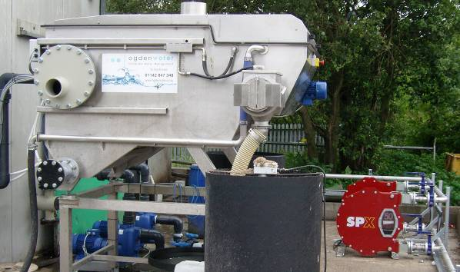

Before:
Solids range, 0 to 5,000 mg/l, average 649 mg/l
COD range, 0 to 12,000 mg/l, average 3970 mg/l

After:
Solids range, 0 to 2,000 mg/l, average 189 mg/l (70% reduction)
COD range, 0 to 12,000 mg/l, average 1965 mg/l (51% reduction)

The resultant sludge from the Filtration System is processed by the existing centrifuge to generate the same dry cake. However, the centrifuge now only needs to run for 8 hours per week

Energy consumption, 70kW, 8 hours per week and 8kW, 168 hours per week @ 10p/kWh = <£200

Energy saving = nearly £1,000 per week

MOGDEN savings as per the numbers above reduced from £600,000 per annum to £320,000

Effluent saving = over £5,000 per week
Other benefits of the Filtration System:

- Small footprint (single car parking space)

- No balance tank – space and CapEx removal from the project

- Almost zero maintenance

- Instant payback relating to reduced CapEx for a smaller DAF

- Reduced chemical consumption for DAF

- Minimal water usage for screen cleaning

The next stage of the project is a DAF plant (2011), followed by biological treatment (2012) and finally, Reverse Osmosis (2013).

